Project Development Phase
Model Performance Test

Date | 30 September 2026
Team ID | SWTID-2026-3708
Project Name | Streamlining IT Procurement: Automating Standard Laptop Orders with Flow Designer
Maximum Marks | 10 Marks
Team Size | 4
Team Leader | A Yashmin
Team Members | Rishwana Parveen S, Deepika Sri M, Pooja S
Submitted by | A Yashmin (Team Leader)

Model Performance Testing:
Project team shall fill the following information in model performance testing template.
S.No. | Parameter | Values | Screenshot
1. | Metrics | Regression Model: MAE - N/A, MSE - N/A, RMSE - N/A, R2 score - N/A  Classification Model: Confusion Matrix - N/A, Accuracy Score - N/A & Classification Report - N/A  No machine-learning model is used in this project, so these metrics do not apply.  Functional result: test order REQ0010001 -> RITM0010001 -> catalog task SCTASK0010001 was created automatically, assigned to the Hardware group, with the expected short description and Approval = Approved. | 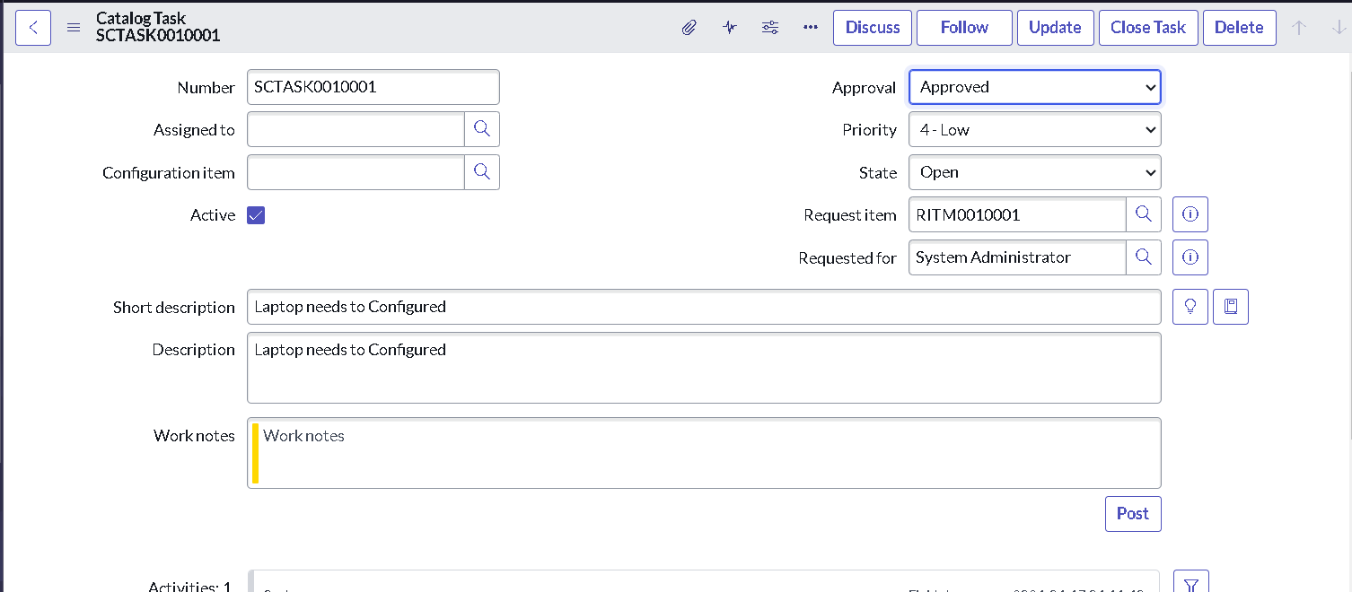  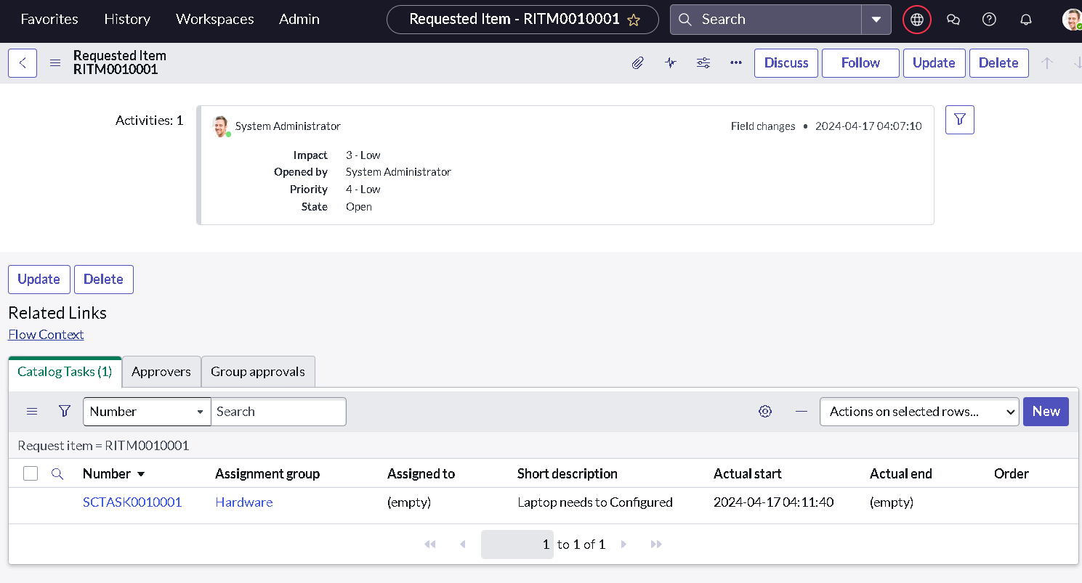
2. | Tune the Model | Hyperparameter Tuning - N/A (rule-based flow)  Validation Method - Manual end-to-end functional validation: order the Standard Laptop from the Service Catalog, approve the request, open the Requested Item and confirm the catalog task is created with the right short description and Hardware assignment group. | 